**Name: - Bishwa Thakuri**

**Level-6 Section-A**

**Course: - Advance Web Engineering**

**ID: - C7227274**

This the default home page

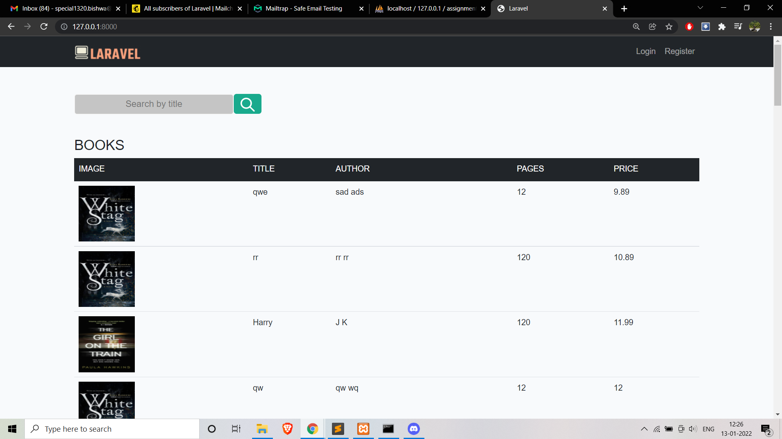

In this page user can see all the product and search different product. From here user can also login or register as new user by clicking the links from the header.

This is the login interface

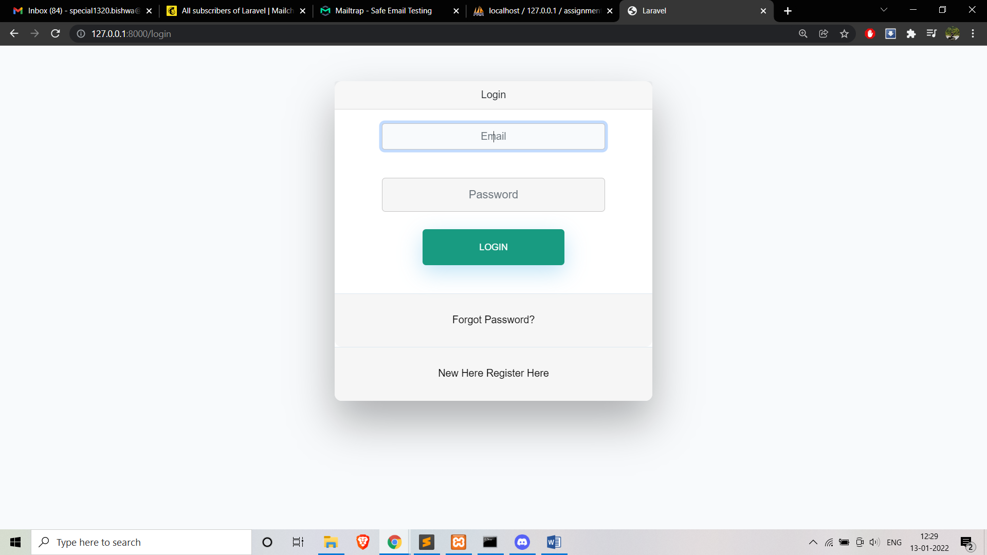

This is the register form

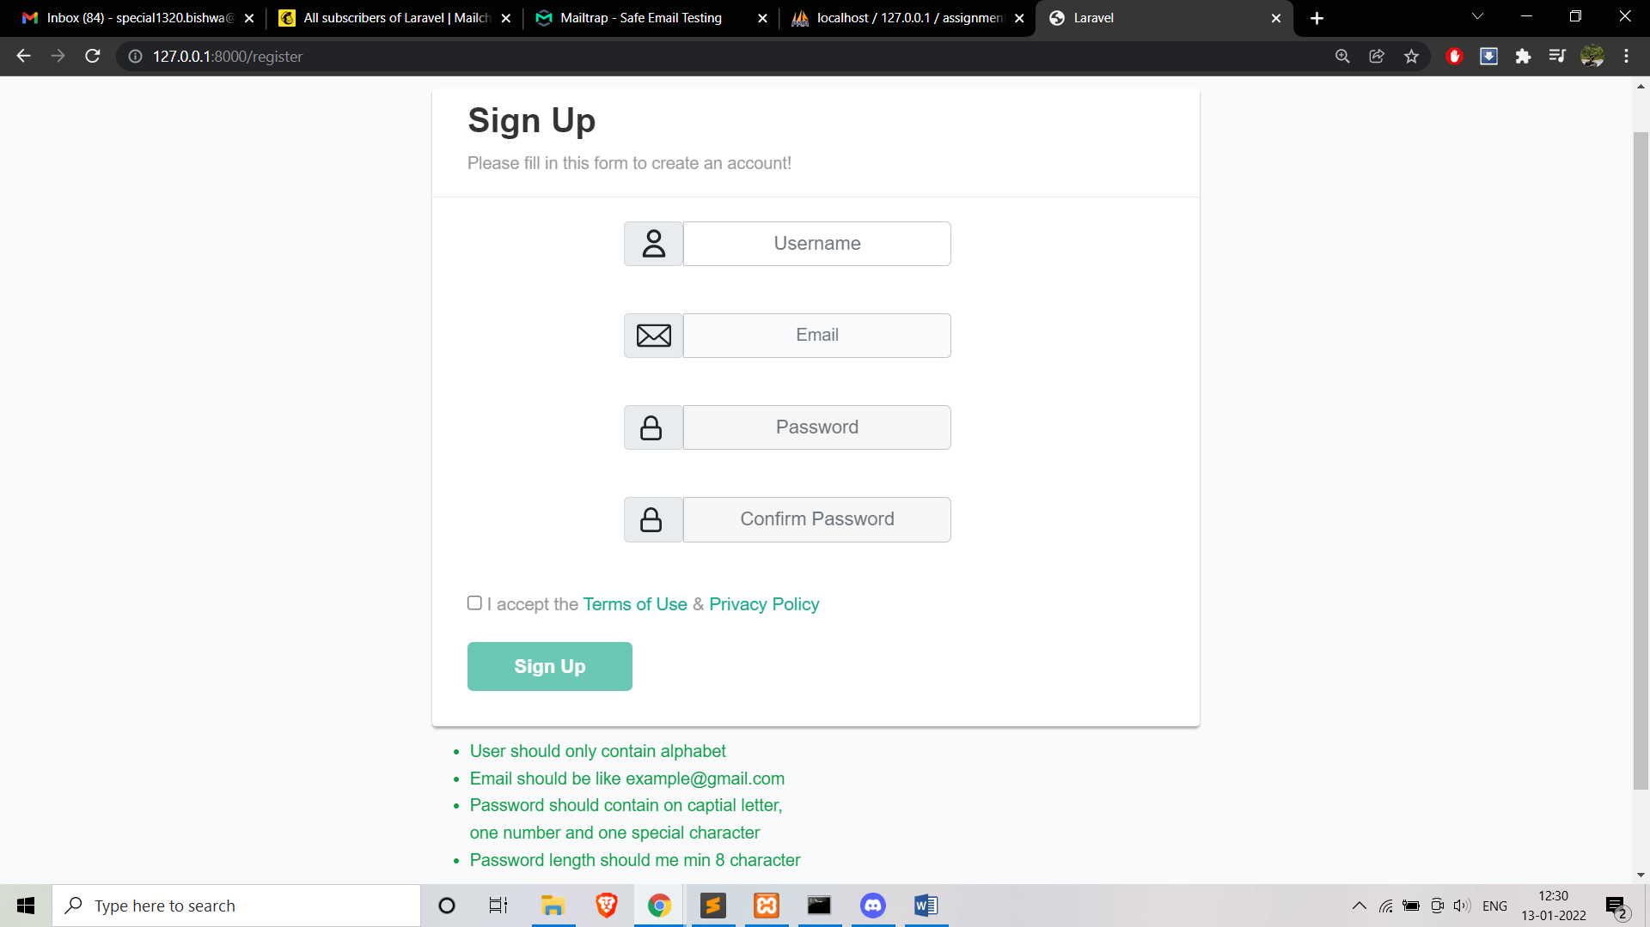

Some of the validation required during the registration are given below in the green colour in the form.

The user profile

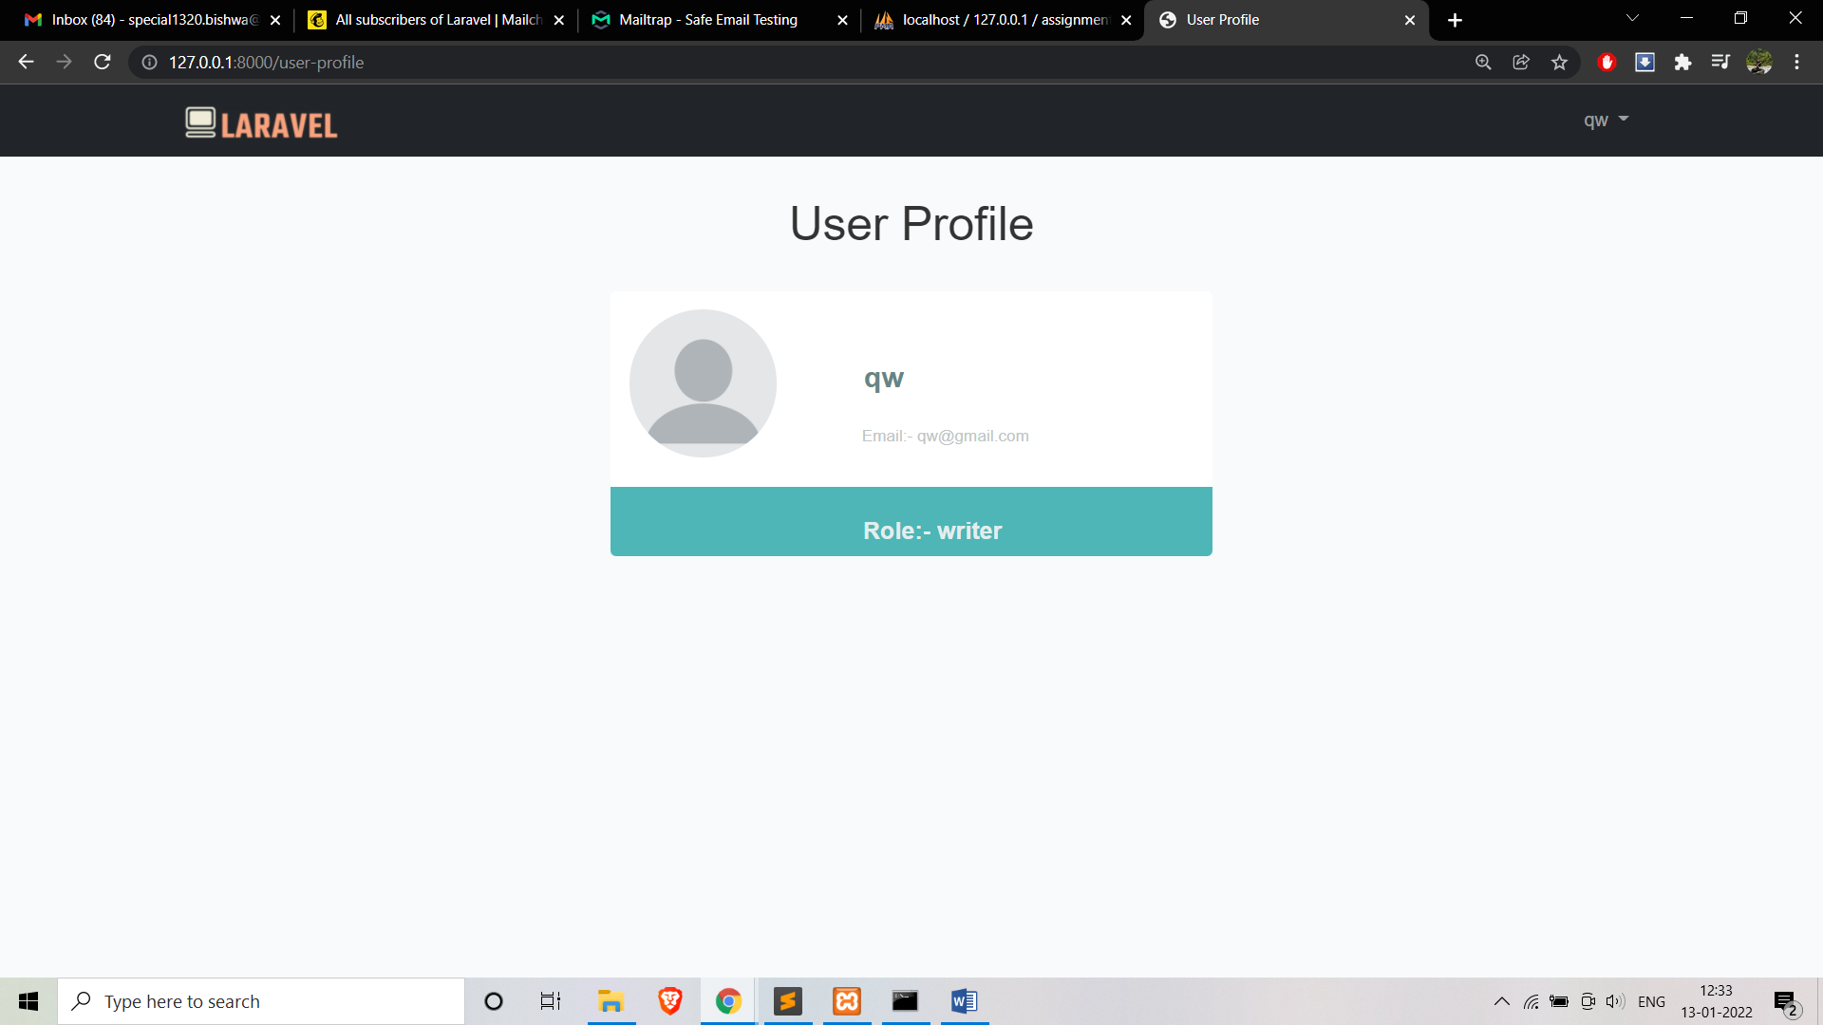

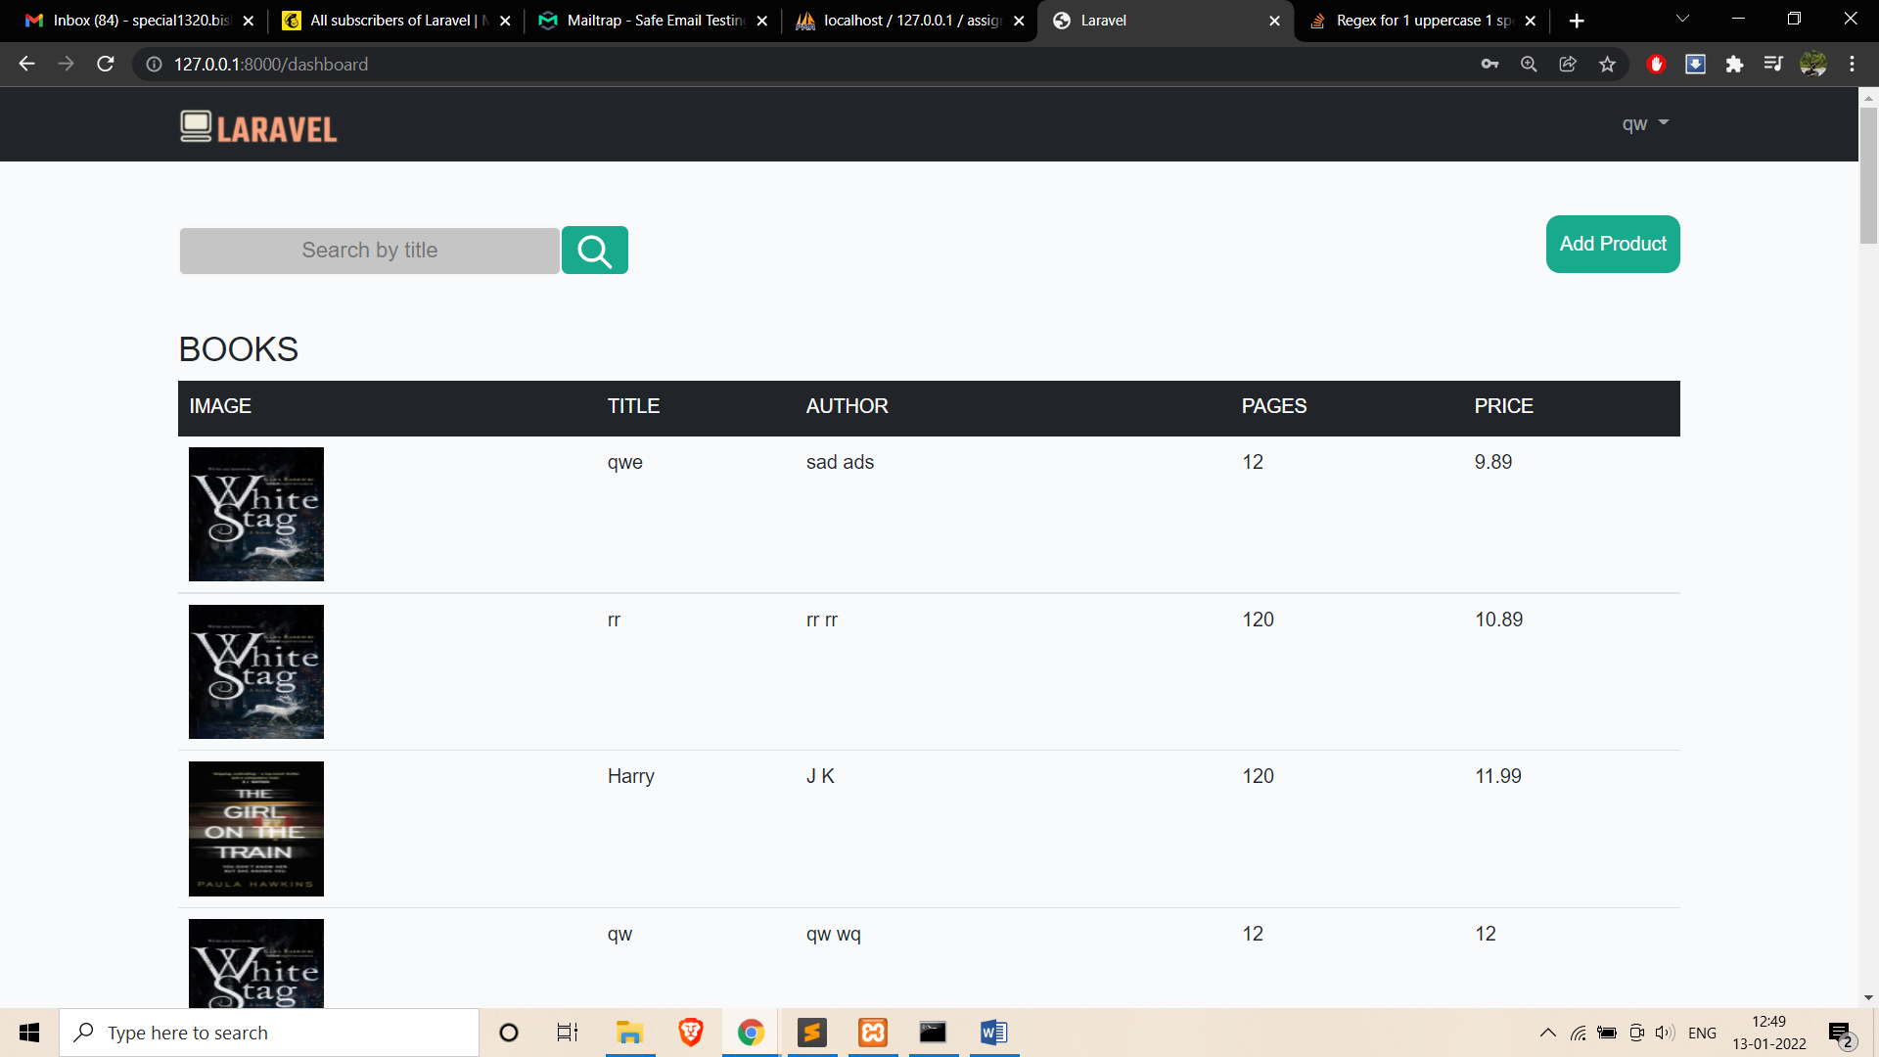

Since the user qw have the role of writer so he can only add product to the database. Only Admin have the right to update and delete the product.

This is the result after the user try to search ‘sa’ from the search bar

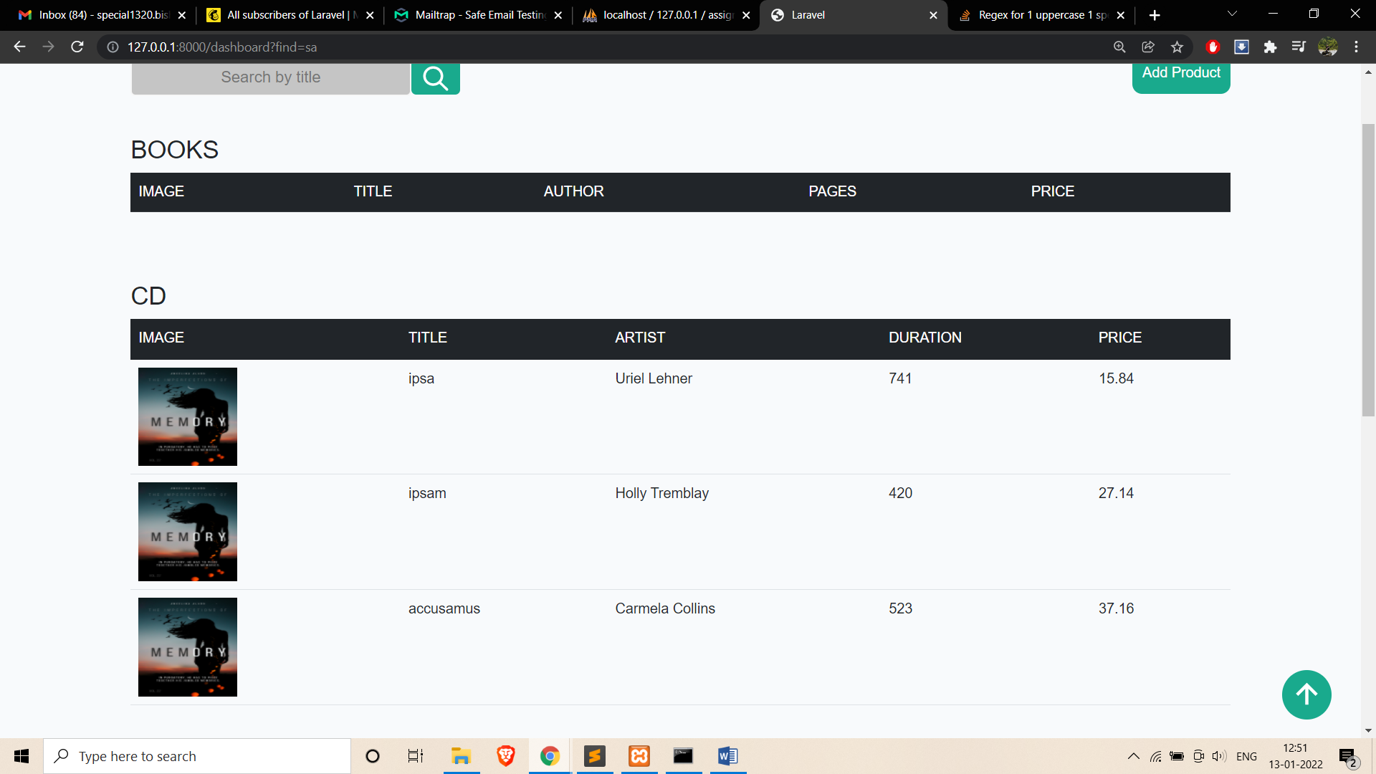

This user can also sort according to tittle and price

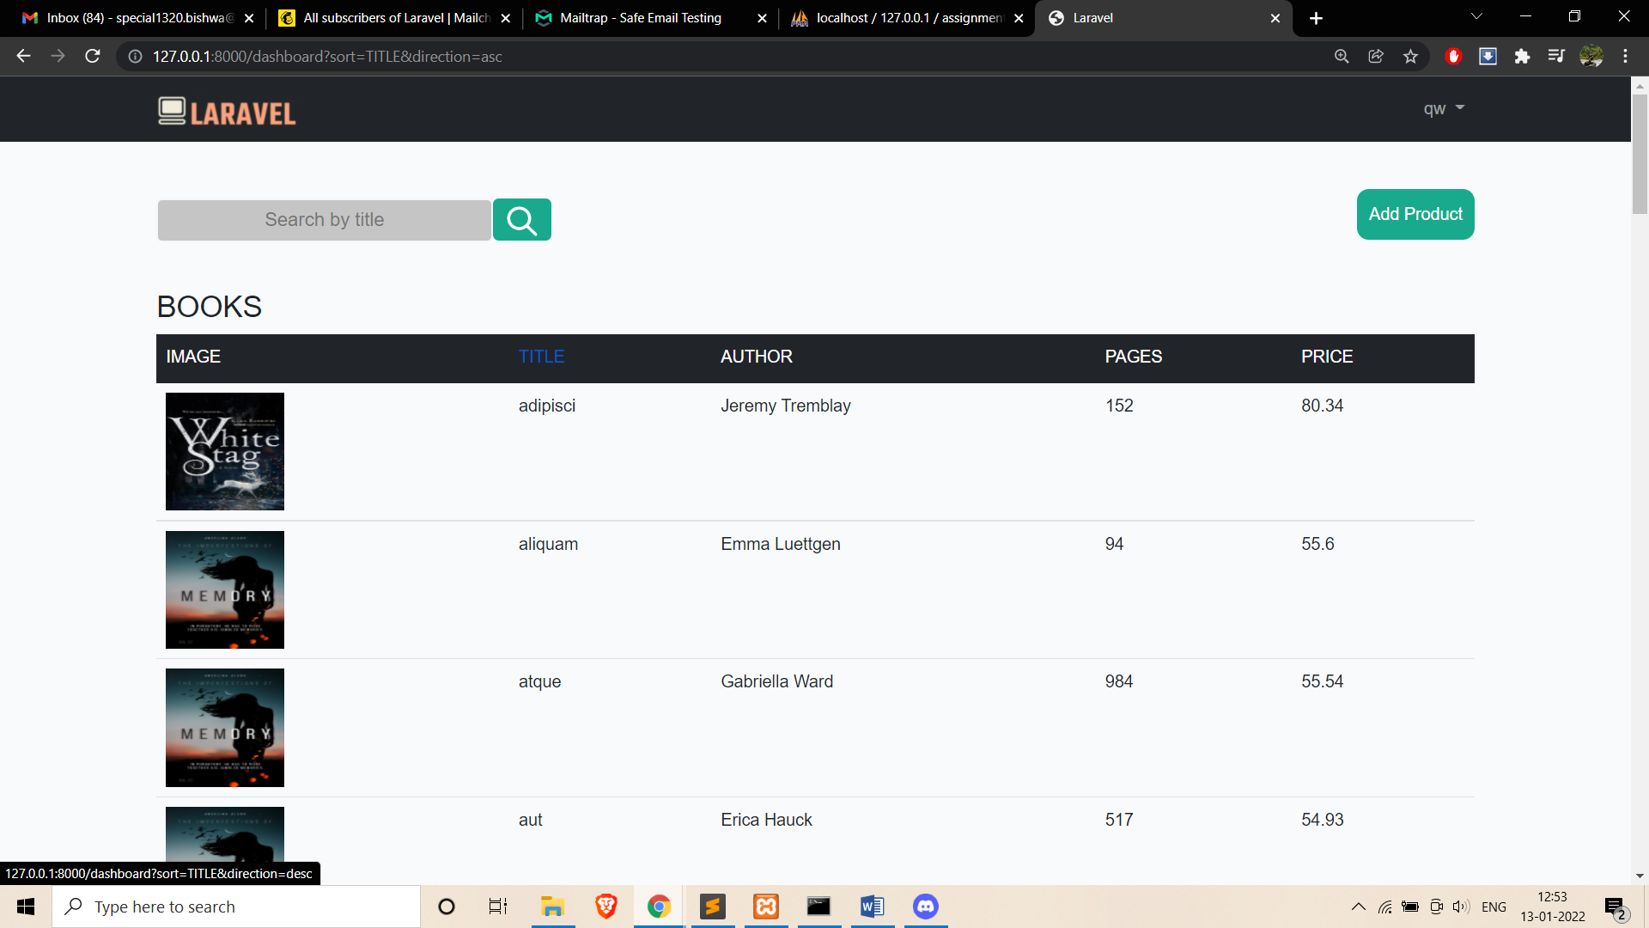

This is the add product form

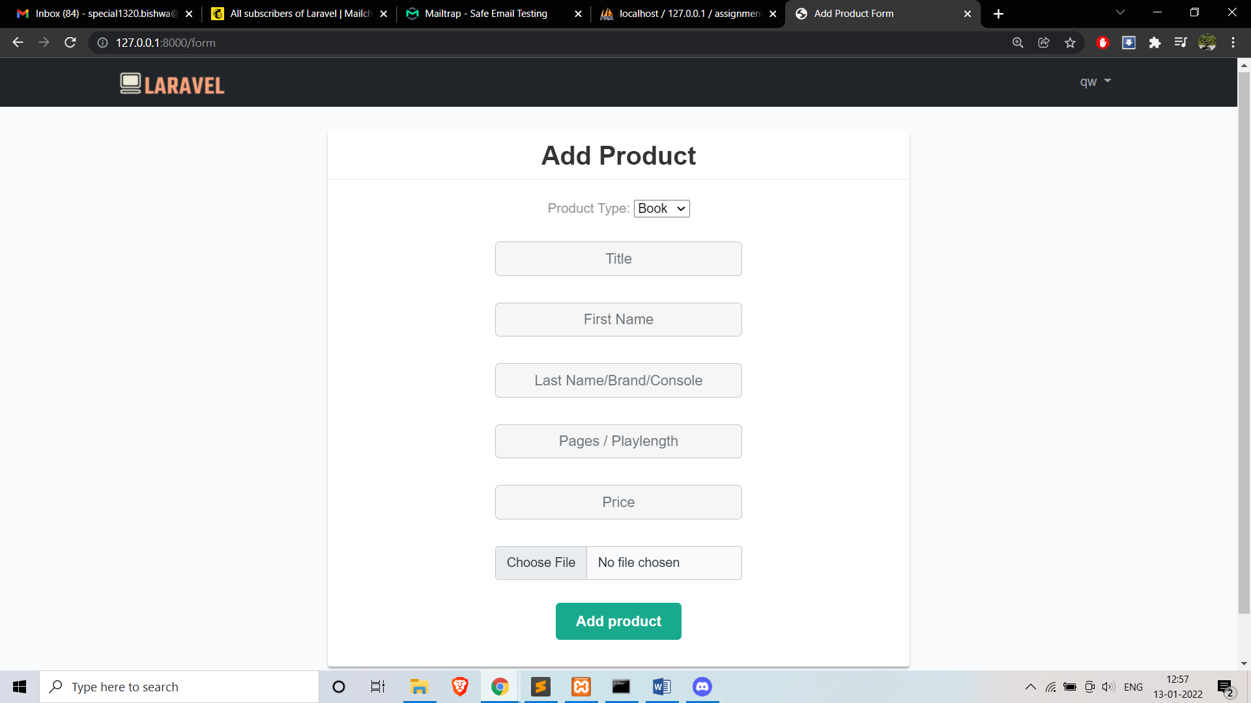

The user have the admin role

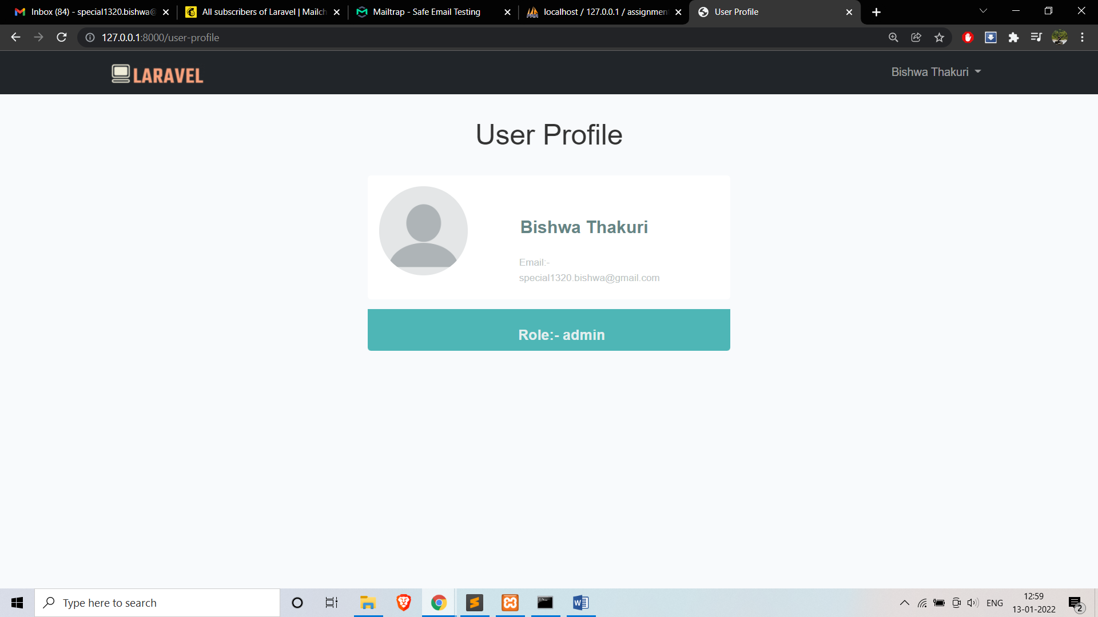

So the admin role user can add or delete product from the database easily

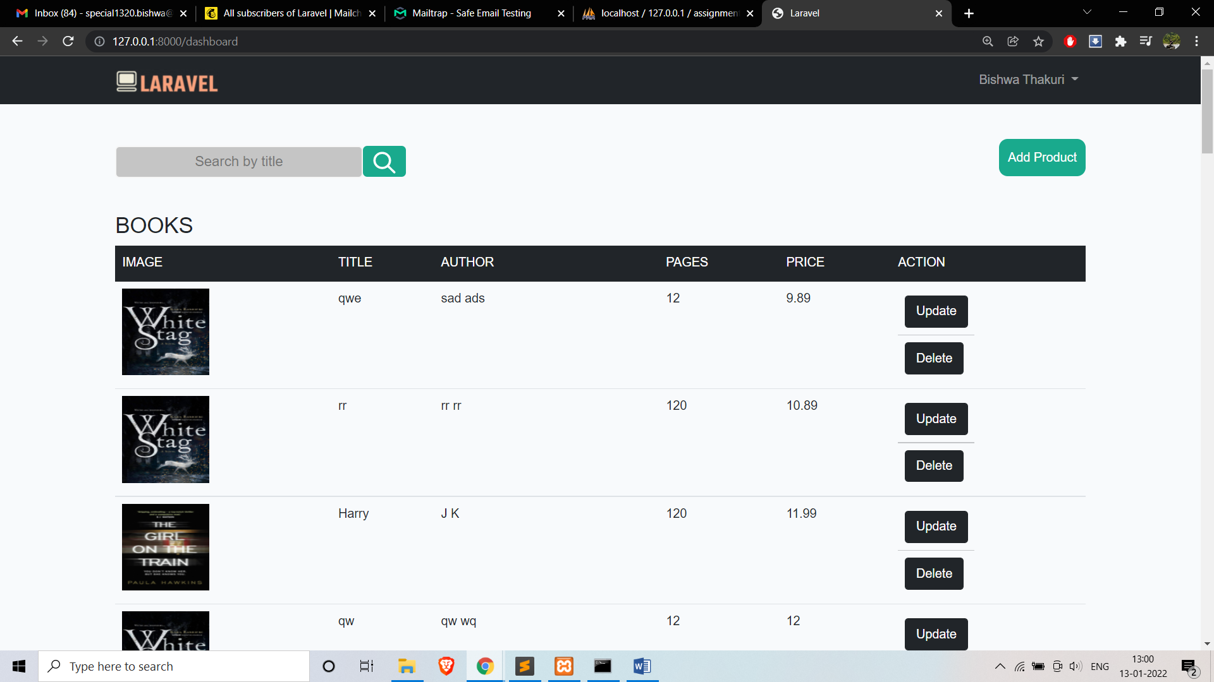

After deleting the product it display this message

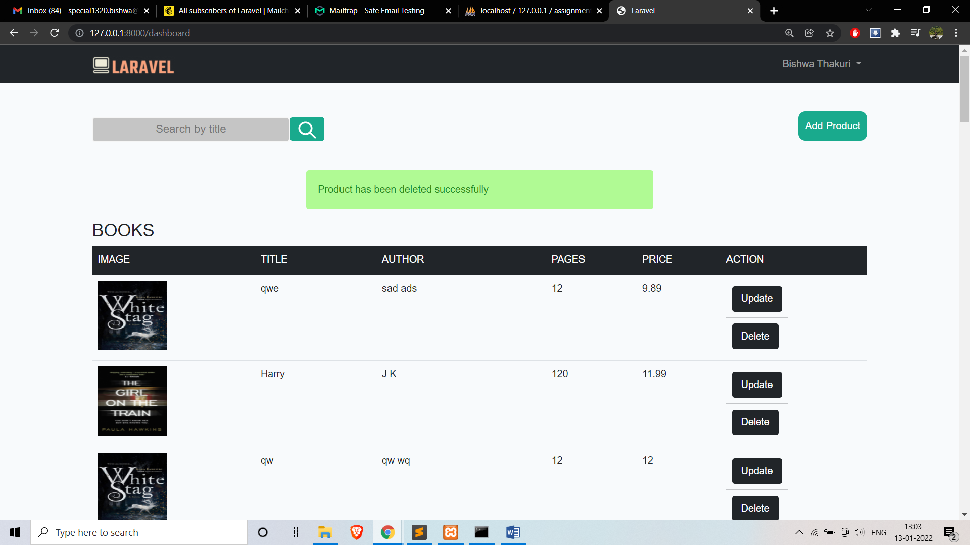

I have also added newsletter using the mailchimp

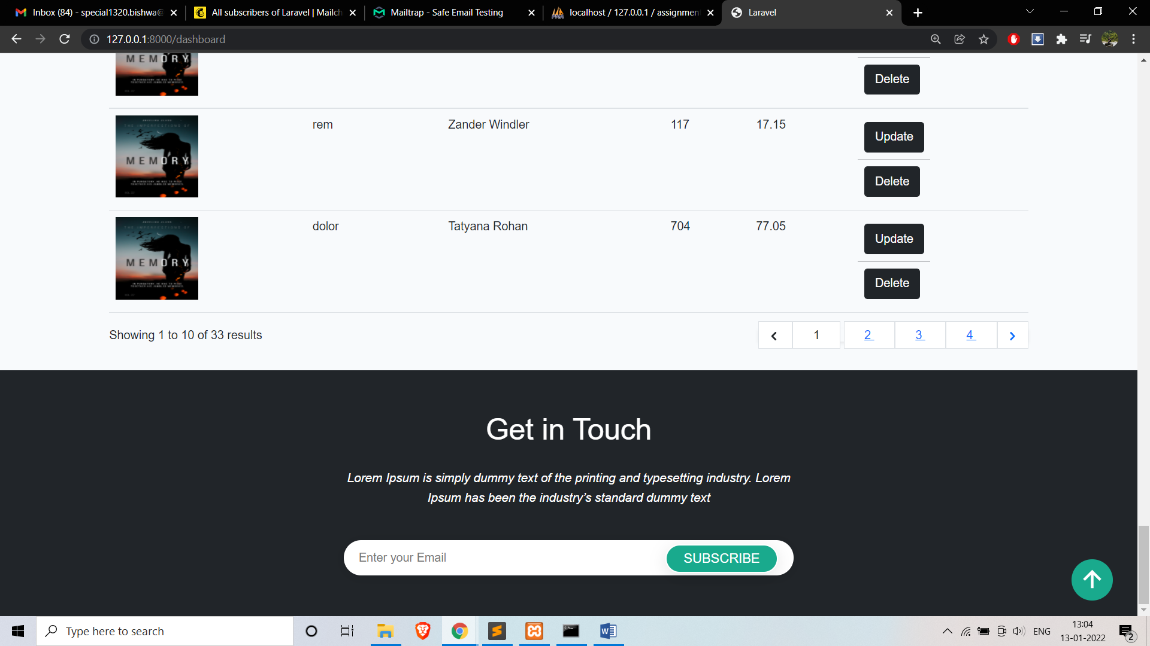

I also have added got to top button in the websites

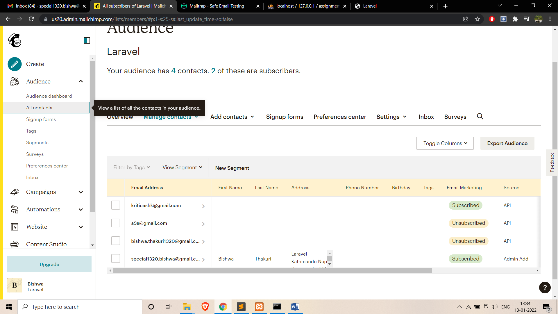

I have also used mailtrap for the email registration verification forget password verification.

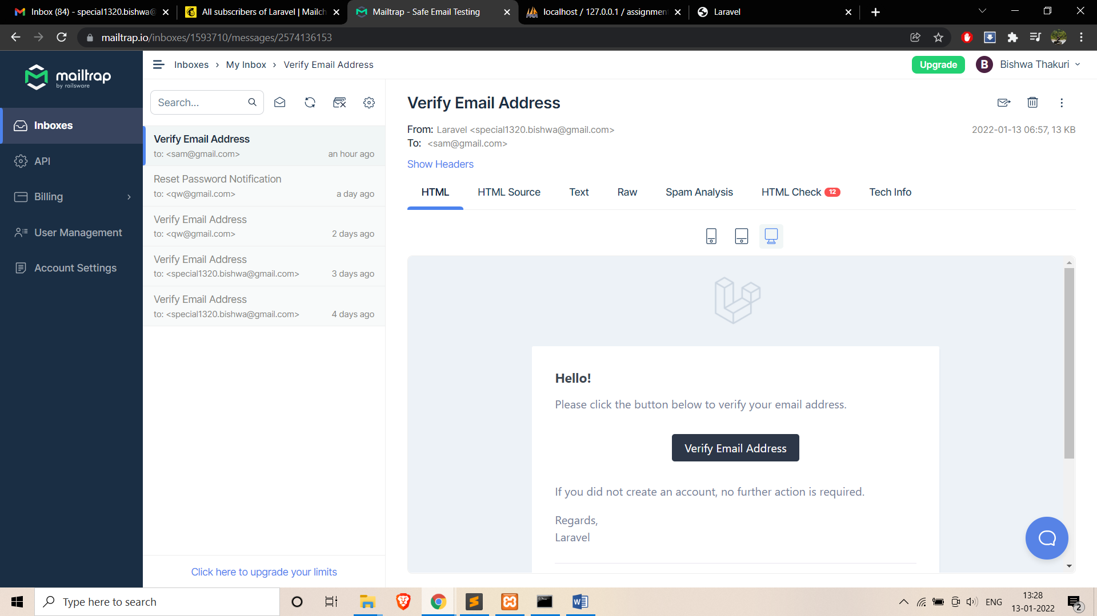

I have used get, post, put and delete in my route file

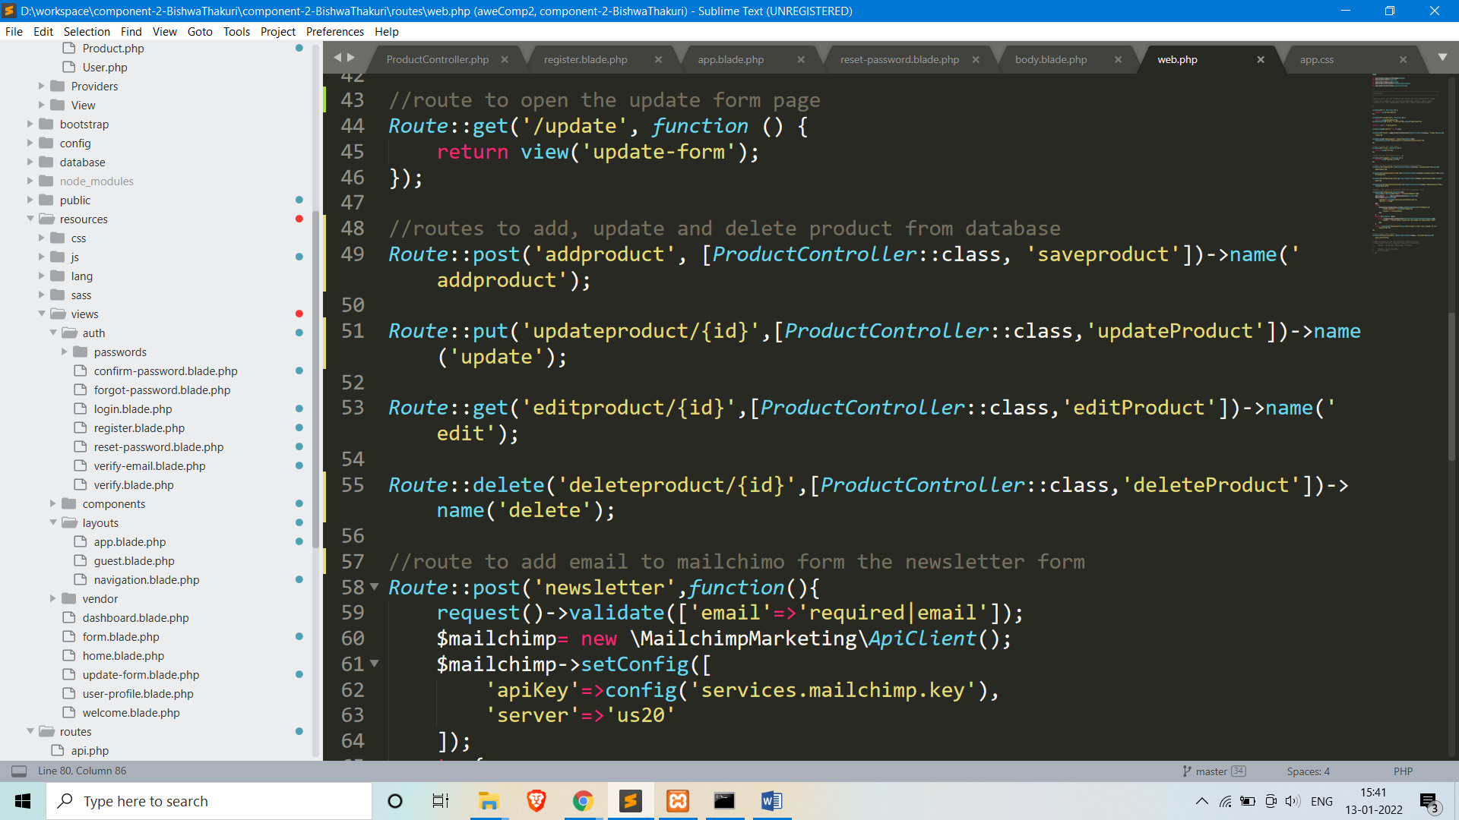

Here is the code to save the product to products table

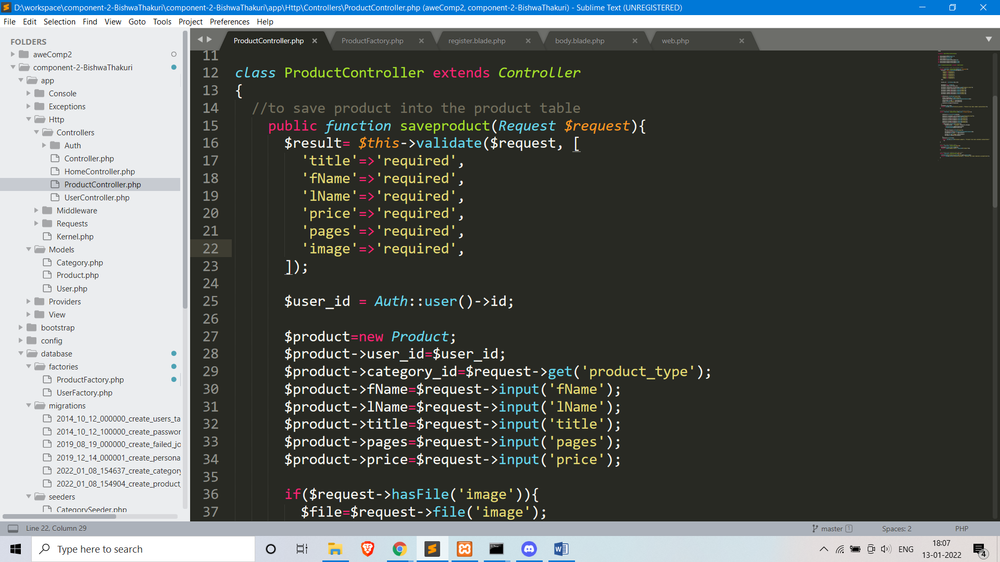

­

Here is the code for the seeding of the product table with 100 data

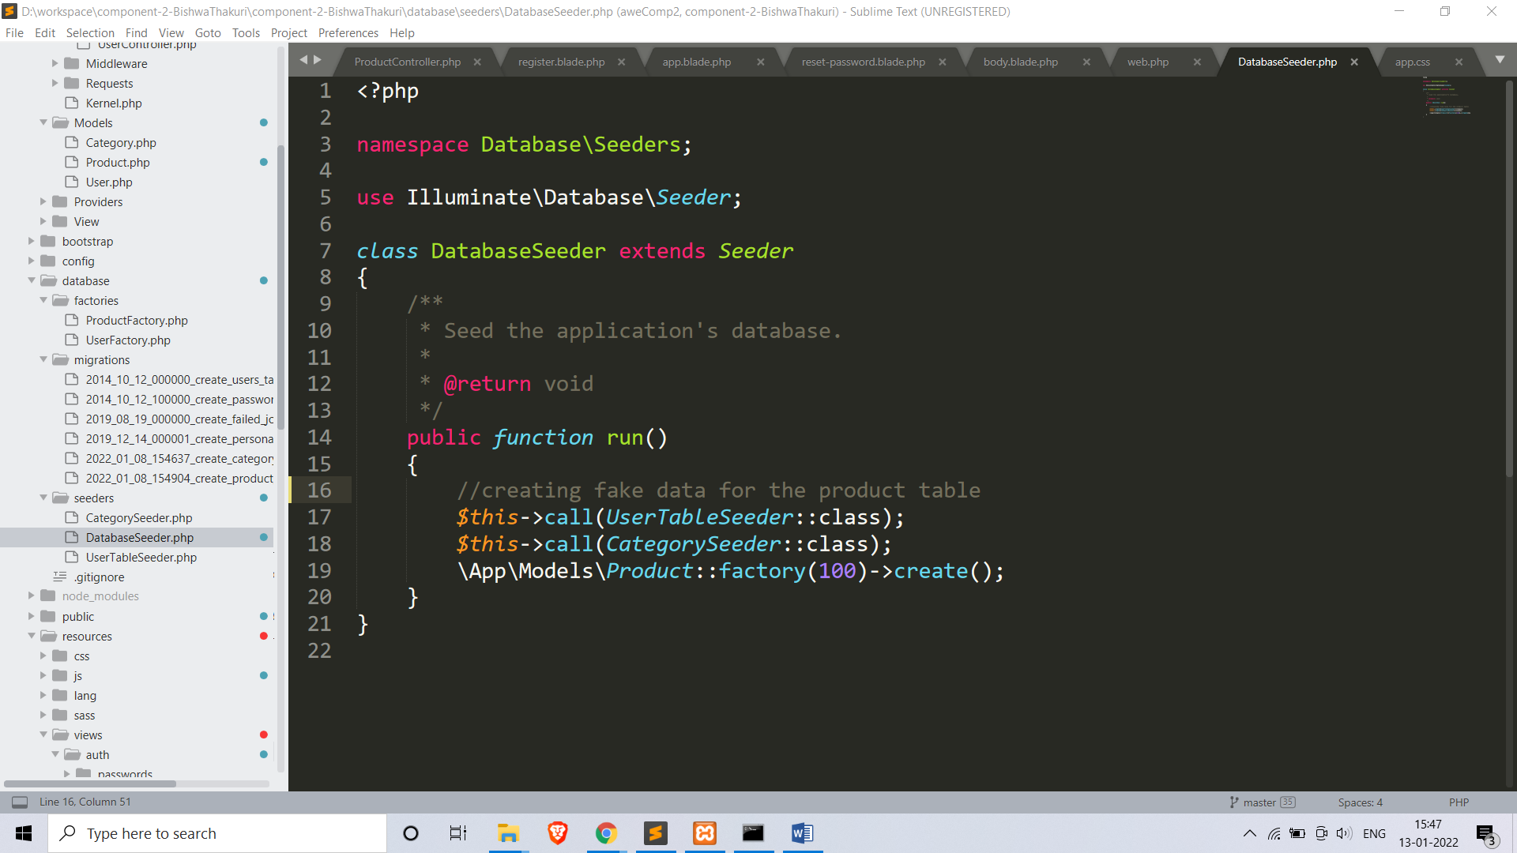

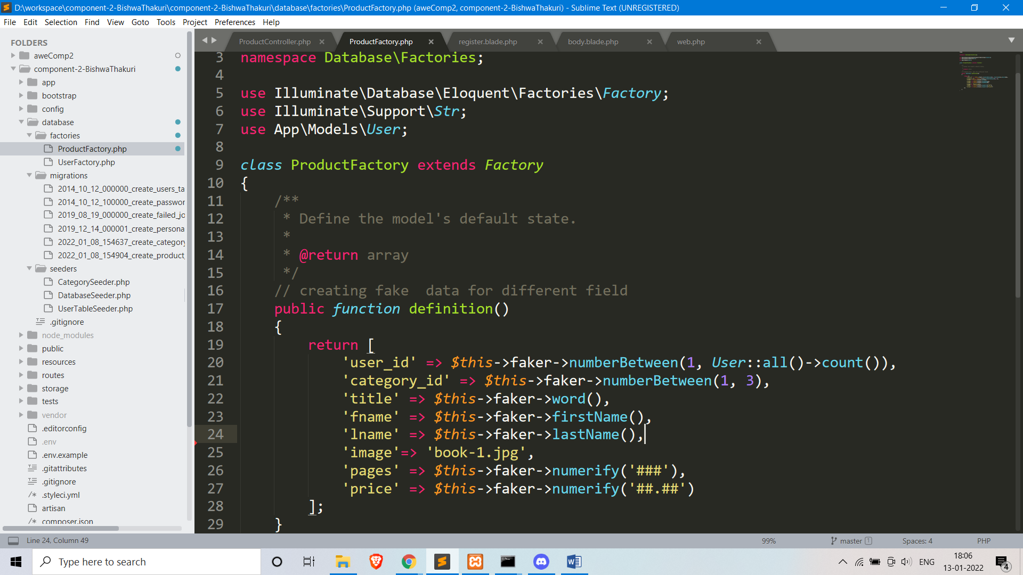

Here is the code for the migration file of the products table

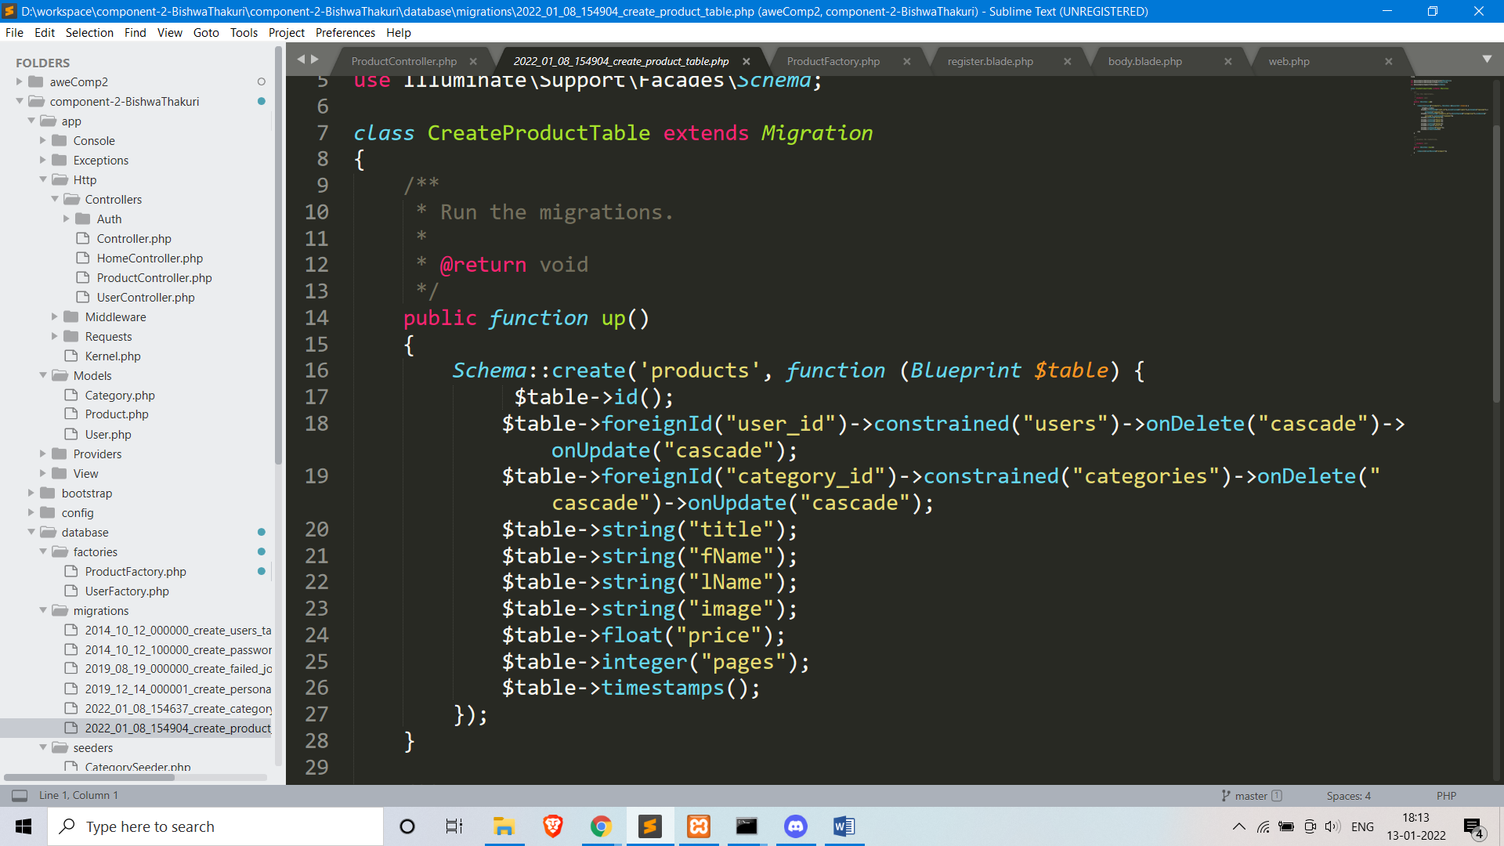

GitHub Link: - https://github.com/tbc-bsc-l6/component-2-BishwaThakuri

MyBeckett GitHub Link: - https://github.com/comp-bkt/component-2-BishwaThakuri

Demo Video Link: - https://www.youtube.com/watch?v=XUAEPr5cmg4&ab_channel=BishwaThakuri